**CC2 Project Report**

**Muzium Negara Trip**  
 **28th May 2023**

PREPARED FOR

**COMMUNITY SERVICE/EVENT ORGANIZING MPU3412**

SURESH SAMINATHAN

PREPARED BY

**GROUP 11**

# **Abstract**

To spread knowledge on the long history of Malaysia and promote its rich culture and heritage, we from group 11 proposed on visiting Muzium Negara. We chose this museum due to its collection of artifacts, handicrafts, musical instruments, and architectural exhibits which piqued our interest. This trip was held on 28th May 2023 with a total of 11 participants. After looking through every part of the museum, we got back to the bus to commence the next activity, which was the quiz. Even though there were a lot of complications from pre-event to post-event, it was addressed eventually which made the trip progress well.

Below are the goals and objectives of our project.

**Goal :**

* To further spread more knowledge on the history, culture, and heritage of Malaysia.
* To give a deeper understanding of the unique culture of Malaysia.
* To amuse participants with activities.
* To be more involved with the community and interact with people that share the same interests.
* To foster curiosity and creativity.
* To raise funds for a greater cause.

**Objectives :**

* To explore the museum’s collection of artifacts, handicrafts, musical instruments, and architectural exhibits
* To attend the museum’s educational exhibits and programs.
* To learn more about the history of Malaysia
* To participate in various activities

**Table of Contents**

**Abstract** i

**1.** **Log of Activities** 1

**Planning** 1

**Implementation** 7

**Post-Mortem** 8

**2.** **Task Division** 9

**2.1 Division of Task** 9

**2.2 Key Personnel** 10

**3.** **Outcome and Recommendation** 11

**4.** **Minutes of Meetings** 12

**Minutes of Meeting (1)** 12

**Minutes of Meeting (2)** 14

**5.** **Appendices** 16

# **Log of Activities**

## **Planning**

|  |  |  |  |
| --- | --- | --- | --- |
| Date | Attendee | Activity | Venue |
| 16/03  20:18 -20:57 | Present :  - ABDULRAHMAN GAMIL MOHAMMED AHMED  - BALKAN DOVRANOV  - DARRSHAN RAAJ A/L VIKNESWARAN  - DARSHRNNEY A/P PUSHPANATHAN  - FAISAL IMTIAZ  - LEE TECK KUAN  - LENNARD THENG ZHENG ZHE  - LOH WEI LOON  - LUBAINA ABDULLAH KHAN  - NICHOLAS HARTONO PUTRA  - SAM ZHENG XUAN  - WESLEY  - YOUSIF MOHAMED ELEID ALI SID AHMED  Absent :  - TAN JIE SHEN  - TAN YEE | - Making a group chat on teams  - Discussing the project we are going to do  - Deciding on the group name | Teams Group Chat |
| 23/03  23:43 – 24/03 00:29 | Present :  - ABDULRAHMAN GAMIL MOHAMMED AHMED  - DARSHNNEY A/P PUSHPANATHAN  - FAISAL IMTIAZ  - LEE TECK KUAN - LENNARD THENG ZHENG ZHE  - LUBAINA ABDULLAH KHAN  - NICHOLAS HARTONO PUTRA  - TAN JIE SHEN  - TAN YEE  - WESLEY  - YOUSIF MOHAMED ELEID ALI SID AHMED  Absent :  - BALKAN DOVRANOV  - DARRSHAN RAAJ A/L VIKNESWARAN  - LOH WEI LOON  - SAM ZHENG XUAN | - Deciding on which museum to go  - Dividing task - Discussing the event | Teams Meeting |
| 03/04  08:10 – 22:07 | Present :  - ABDULRAHMAN GAMIL MOHAMMED AHMED  - BALKAN DOVRANOV  - DARRSHAN RAAJ A/L VIKNESWARAN  - DARSHRNNEY A/P PUSHPANATHAN  - FAISAL IMTIAZ  - LEE TECK KUAN  - LUBAINA ABDULLAH KHAN  - NICHOLAS HARTONO PUTRA  - WESLEY | - Discussing the time to carry out the event | Whatsapp Group Chat |
| 04/04 23:19 | - ABDULRAHMAN GAMIL MOHAMMED AHMED  - BALKAN DOVRANOV  - DARRSHAN RAAJ A/L VIKNESWARAN  - FAISAL IMTIAZ  - LEE TECK KUAN  - LENNARD THENG ZHENG ZHE  - LOH WEI LOON  - LUBAINA ABDULLAH KHAN  - NICHOLAS HARTONO PUTRA  - SAM ZHENG XUAN  - TAN YEE  - WESLEY  - YOUSIF MOHAMED ELEID ALI SID AHMED  Absent :  - DARSHNNEY A/P PUSHPANATHAN  - TAN JIE SHEN | - Elaborating more on the key personnel and task | Teams Meeting |
| 14/04 | - ABDULRAHMAN GAMIL MOHAMMED AHMED  - DARRSHAN RAAJ A/L VIKNESWARAN  - FAISAL IMTIAZ  - NICHOLAS HARTONO PUTRA  - TAN YEE  - WESLEY | - Presentation on the event proposal with supervisor  - Discussion regarding the bus | Teams Meeting |
| 15/04 | Present :  - ABDULRAHMAN GAMIL MOHAMMED AHMED  - DARRSHAN RAAJ A/L VIKNESWARAN  - DARSHNNEY A/P PUSHPANATHAN  - FAISAL IMTIAZ  - SAM ZHENG XUAN  Absent :  - BALKAN DOVRANOV  - LEE TECK KUAN  - LENNARD THENG ZHENG ZHE  - LOH WEI LOON  - LUBAINA ABDULLAH KHAN  - NICHOLAS HARTONO PUTRA  - TAN YEE  - TAN JIE SHEN  - WESLEY  - YOUSIF MOHAMED ELEID ALI SID AHMED | - Discussing about the fees and budget | Teams Group Chat |
| 30/4 | Present :  - DARRSHAN RAAJ A/L VIKNESWARAN  - DARSHNNEY A/P PUSHPANATHAN  - FAISAL IMTIAZ  - WESLEY  - YOUSIF MOHAMED ELEID ALI SID AHMED  - NICHOLAS HARTONO PUTRA  Absent :  - ABDULRAHMAN GAMIL MOHAMMED AHMED  - BALKAN DOVRANOV  - LEE TECK KUAN  - LENNARD THENG ZHENG ZHE  - LOH WEI LOON  - LUBAINA ABDULLAH KHAN  - NICHOLAS HARTONO PUTRA  - SAM ZHENG XUAN  - TAN YEE  - TAN JIE SHEN | - Discussing the time to carry out the event and how to promote  - Making forms | Teams Group Chat |
| 06/05 | Present :  - ABDULRAHMAN GAMIL MOHAMMED AHMED  - DARRSHAN RAAJ A/J - VIKNESWARAN  - DARSHNNEY A/P PUSHPANATHAN  - FAISAL IMTIAZ  - LEE TECK KUAN  - LOH WEI LOON  - NICHOLAS HARTONO PUTRA  - TAN JIE SHEN  - WESLEY  - YOUSIF MOHAMED ELEID ALI SID AHMED  Absent :  - BALKAN DOVRANOV  - LENNARD THENG ZHENG ZHE  - LUBAINA ABDULLAH KHAN  - SAM ZHENG XUAN  - TAN YEE | - Discussing about promotion, date of the event, participant’s drinks, poster, quiz  - Making QR code | Teams Meeting |
| 09/05 | - LOH WEI LOON  - TAN YEE | - Making Instagram account for promoting the event  - Finishing the quiz | Instagram |
| 10/05 | Present :  - DARSHNNEY A/P PUSHPANATHAN  - FAISAL IMTIAZ  - LOH WEI LOON  - SAM ZHENG XUAN  - WESLEY  Absent :  - ABDULRAHMAN GAMIL MOHAMMED AHMED  - BALKAN DOVRANOV  - DARRSHAN RAAJ A/L VIKNESWARAN  - LEE TECK KUAN  - LENNARD THENG ZHENG ZHE  - LUBAINA ABDULLAH KHAN  - NICHOLAS HARTONO PUTRA  - TAN JIE SHEN  - TAN YEE  - YOUSIF MOHAMED ELEID ALI SID AHMED | - Discussing about the booking the bus | Teams Group Chat |
| 12/05 | Present :  - DARSHRNNEY A/P PUSHPANATHAN  - WESLEY  Absent :  - ABDULRAHMAN GAMIL MOHAMMED AHMED  - BALKAN DOVRANOV  - DARRSHAN RAAJ A/L VIKNESWARAN  - FAISAL IMTIAZ  - LEE TECK KUAN  - LENNARD THENG ZHENG ZHE  - LOH WEI LOON  - LUBAINA ABDULLAH KHAN  - NICHOLAS HARTONO PUTRA  - SAM ZHENG XUAN  - TAN JIE SHEN  - TAN YEE  - YOUSIF MOHAMED ELEID ALI SID AHMED | - Final decision on setting the date of carrying out the event | Teams Group Chat |
| 27/05 | Present :  - ABDULRAHMAN GAMIL MOHAMMED AHMED  - BALKAN DOVRANOV  - DARRSHAN RAAJ A/L VIKNESWARAN  - DARSHRNNEY A/P PUSHPANATHAN  - FAISAL IMTIAZ  - LOH WEI LOON  - NICHOLAS HARTONO PUTRA  - TAN YEE  - WESLEY  - YOUSIF MOHAMED ELEID ALI SID AHMED  Absent :  - LEE TECK KUAN  - LENNARD THENG ZHENG ZHE  - LUBAINA ABDULLAH KHAN  - SAM ZHENG XUAN  - TAN JIE SHEN | - Purchasing buns and prize for quiz  - Discussing about the number of people joining the event | Teams Group Chat |

## **Implementation**

Event Day 28th May

|  |  |  |  |
| --- | --- | --- | --- |
| Time | Attendees | Activity | Venue |
| 10:00–10:30 | Present :  - ABDULRAHMAN GAMIL MOHAMMED AHMED  - DARRSHAN RAAJ A/L VIKNESWARAN  - DARSHNNEY A/P PUSHPANATHAN  - FAISAL IMTIAZ  - LEE TECK KUAN  - LOH WEI LOON  - LUBAINA ABDULLAH KHAN  - NICHOLAS HARTONO PUTRA  - WESLEY  - YOUSIF MOHAMED ELEID ALI SID AHMED  Absent :  - BALKAN DOVRANOV  - LENNARD THENG ZHENG ZHE  - SAM ZHENG XUAN  - TAN JIE SHEN  - TAN YEE | -Gathering Participants at APU lobby  -Waiting for Bus | Muzium Negara |
| 10:30–11:00 | -Depart to Museum Negara |
| 11:00-13:00 | -Museum Tour |
| 13:00.–13:30 | -Gathering Participants for Group Photo  -Waiting for Bus to head back |
| 13:30–14:00 | -Depart to APU  -Quiz Session  -Give out the prize for the winner of Quiz  -Feedback Form |

## **Post-Mortem**

|  |  |  |  |
| --- | --- | --- | --- |
| Date | Attendee | Activity | Venue |
| 28/05 | DARSHRNNEY A/P PUSHPANATHAN | - Calculating the money acquired |  |
| NICHOLAS HARTONO PUTRA | - Calculating the expenses and profits acquired |  |
| 27/06-28/06 | Present :  - ABDULRAHMAN GAMIL MOHAMMED AHMED  - BALKAN DOVRANOV  - DARRSHAN RAAJ A/L VIKNESWARAN  - DARSHNNEY A/P PUSHPANATHAN  - LEE TECK KUAN  - LENNARD THENG ZHENG ZHE  - LOH WEI LOON  - LUBAINA ABDULLAH KHAN  - NICHOLAS HARTONO PUTRA  - TAN YEE  - WESLEY  Absent:  - FAISAL IMTIAZ  - YOUSIF MOHAMED ELEID ALI SID AHMED  - SAM ZHENG XUAN  - TAN JIE SHEN | - Discussion on presentation  - Making ppt slides  - Video Recording | Teams Group Chat |

# **Task Division**

## **2.1 Division of Task**

|  |  |  |  |  |
| --- | --- | --- | --- | --- |
| **NO** | **NAME** | **TP NUMBER** | **TASK ALLOCATED** | **SIGN** |
| **1.** | ABDULRAHMAN GAMIL MOHAMMED AHMED | TP071012 | -Minutes of meetings.  - Arrange the meetings.  - Attend the event.  - Direct the participants.  - Arranging bus transportation (with WESLEY) |  |
| **2.** | BALKAN DOVRANOV | TP066245 | - Contacting Muzium Negara in order to get information no tickets, their working dates, is our trip possible and if we need to take care of additional things (with Darrshan)  - Helping with the marketing | ***Balkan*** |
| **3.** | DARRSHAN RAAJ A/J VIKNESWARAN |  | - Calling the museum to ask about prices  - Gathering sponsors for food and drinks  - Photography on event day  - Attend the event. |  |
| **4.** | DARSHRNNEY A/P PUSHPANATHAN | TP072253 | - Registering participants  -Collecting money from participants  -Creating the google form(All from design , to information , to payment, etc.)  - Making sure we are on schedule  -Giving all the information to the participants (By directing them , making a group chat , answering any questions they had, etc.)  - Writing report: (Appendices), (reviewing what members have written down )  -Advertise thru Microsoft Teams (APU – All clubs and APU students )  - Attend the event. |  |
| **5.** | FAISAL IMTIAZ |  | * Trip Idea. * Poster Advertisement (thru Instagram) * Managing and keeping track of Students. * Direct the participants. * Presentation – Implementation and Post-mortem. * Attend the event. |  |
| **6.** | LEE TECK KUAN |  | - Make Gantt chart  - Attend the event |  |
| **7.** | LENNARD THENG ZHENG ZHE |  | - Creating Timetable  - Making Quiz |  |
| **8.** | LOH WEI LOON |  | - Made Google Form to select targeted audience for promoting  - In charge of marketing - Made Instagram account to promote  - Attend the event |  |
| **9.** | LUBAINA ABDULLAH KHAN |  | -Doing the initial budget(idea)  -Did the report slides for video presentation  - Attend the event. |  |
| **10.** | NICHOLAS HARTONO PUTRA | TP067308 | - Making the proposal (Summary, Introduction, Features, Key Personnel, Copy the timetable to Estimated itinerary)  - Making Budget file  - Making ppt file for proposal presentation  - Gave clear instructions to the task division (Making clear roles)  - Making the report file (Log of activities, template for task division, Key Personnel diagram, Abstract, Outcome and recommendation, finishing touches on the appendix)  - Contacted the supervisor to book a consultation for presenting our proposal  - Calculate the profits gained  - Gather data and calculate on money spent for budget and actual expenses  - Gather data on money obtained  - Advertise the event through chat  - Make QR code for registration  - Attend the event |  |
| **11.** | SAM ZHENG XUAN | TP070497 | - Design the Event Poster  - Transportation Detail Consult  - Optimizing the Google Form(ideas)  - Creating Social Media Account  - Poster Advertisement  - Finding sponsors  - Optimizing the outcomes and recommendations | ***SAM*** |
| **12.** | TAN JIE SHEN |  |  |  |
| **13.** | TAN YEE |  | - Making Quiz  - Buying Prize |  |
| **14.** | WESLEY |  | - Arranging bus transportation. - Making up schedule for the bus to execute the event.  - Attend the event. | ***Wesley*** |
| **15.** | YOUSIF MOHAMED ELEID ALI SID AHMED | TP071163 | - Attend the event. |  |

## **2.2 Key Personnel**

# **Outcome and Recommendation**

The museum trip event to Museum Negara Malaysia was a valuable learning experience. The event provided an excellent opportunity for participants to engage with history and culture through the museum tour. Participants gained insights into various aspects of Malaysia's rich heritage, fostering a deeper appreciation for the country's diverse traditions and history. With a team of 15 individuals involved in organizing and participating in the event, there was a strong sense of engagement and active participation throughout. The participants actively interacted with the exhibits, asked questions, and demonstrated enthusiasm for learning.

However, throughout the process of the event from planning to implementation, we encountered several problems regarding our group and the event. The first problem we encountered is not allocating tasks to members properly. Lack of communication between members was the primary cause of this complication which slowed down the progress. Without clear responsibilities and roles, the team was not able to contribute to the event properly. As a result, there were some crucial tasks left unattended, and we needed another member to cover for them.

The second problem is ambiguity in deciding the date to hold our event. It was supposed to be executed in early May, however, due to some complications the bus was not booked, and we have not promoted the event yet. After several weeks of discussions and waiting for a reply in ordering the bus, we finally set an exact date and the request for the bus was accepted by APU. This problem arises because of the first problem and miscommunication which hinders the event’s progress.

Finally, the last outcome is finding a common time to have a meeting. It was hard to find time to discuss when everyone was free to meet and discuss crucial issues. Due to this problem, some of the members could not make it in time for our meetings and missed some information. This leads to the first problem again, which makes it hard to address emerging issues and impacted our group efficiency.

To address all three of our outcomes, we had to create recommendations or solutions. One of them is that we recognized the importance of establishing clear communications. To overcome this, after every meeting we had written the conclusions of our meeting and listed out the issues in our teams' group. By improving our communications, our efficiency was improved, which effectively addresses all our issues. We also had more group chat discussions after taking everyone’s schedule into account.

The second solution that we have come up with is to implement a structured task assignment system and correctly assign roles. Every task that the members do was sent into the group chat to be evaluated which minimizes emerging issues. We also uploaded a word file in teams so that every member can see the changes and give comments on specific parts. This allowed us to share responsibility and keep an eye on progress more effectively. With this system, everyone has a clear idea of what they must do.

Other than that, there are also some recommendations to improve the participation satisfaction, which is we can diversify the activities. To cater to different learning preferences and interests, explore additional activities to complement the museum tour. This could include guest speakers, interactive workshops, or hands-on demonstrations, allowing participants to engage with history in a more immersive and dynamic manner. We can also consider incorporating sustainability practices into the event, such as reducing waste and promoting eco-friendly behaviors. This can include encouraging participants to bring reusable water bottles or food from home to increase their impact on sustainability.

# **Minutes of Meetings**

## **Minutes of Meeting (1)**

|  |  |  |
| --- | --- | --- |
| Group 11 | Co-curricular Studies MPU 3412 | School of General Studies |

Date : 23/3/2023   
Time : 11.45 P.M   
Venue : MS-TEAMS

**ATTENDANCE**

Present:

|  |  |
| --- | --- |
| 1. ABDULRAHMAN GAMIL MOHAMMED AHMED | Present. |
| 1. DARSHNNEY A/P PUSHPANATHAN | Present. |
| 1. LUBAINA ABDULLAH KHAN | Present. |
| 1. YOUSIF MOHAMMED ELEID ALI SID AHMED | Present. |
| 1. FAISAL IMTIAZ | Present. |
| 1. WESELY | Present. |
| 1. TAN JIE SHEN | Present. |
| 1. LEE TECH KUAN | Present. |
| 1. NICHOLAS HARTONO PUTURA | Present. |
| 1. TAN YEE | Present. |
| 1. LENNARD THENG ZHENG ZHE | Present. |

Absent:

|  |  |
| --- | --- |
| 1. LOH WEI LOON | Absent. |
| 1. BALKAN DOVRANOV | Absent. |
| 1. SAM ZHENG XUAN | Absent. |

Absent with reason:

|  |  |
| --- | --- |
| 1. DARRSHAN RAAJ A/J VIKNESWARAN | Traveling to Ipoh (Emergency leave) |

|  |  |  |  |
| --- | --- | --- | --- |
| No | Description | Action | Date |
| 1.0 | Doing the “key personnel”. | everyone is divided into some roles. | 23/3/2023&  24/3/2023 |
| 2.0 | Which museum we will go to? | Negara Museum. | 23/3/2023&  24/3/2023 |
| 3.0 | * 1. FEE calculation / How many students are we aiming for.   2. Transport.   3. water supplier and Buns.   4. timetable of the day trip.   5. Gantt chart. | We expect 40 students will register.  One bus is enough.  Publish the Timetable and Gantt Chart | 23/3/2023&  24/3/2023 |
| 4.0 | The meeting started at about 11.45 pm. | 45 minutes. | 23/3/2023 |
| 5.0 | The Meeting ended at about 12.30 am. | 45 minutes. | 24/3/2023 |

Minutes prepared by:

Name: Abdulrahman Gamil Mohammed Ahmed.

Secretary: Abdulrahman Gamil Mohammed Ahmed.

Date: 24/3/2023

## **Minutes of Meeting (2)**

|  |  |  |
| --- | --- | --- |
| Group 11 | Co-curricular Studies MPU 3412 | School of General Studies |

Date : 6/5/2023   
Time : 9.30 P.M   
Venue : MS-TEAMS

**ATTENDANCE**

Present:

|  |  |
| --- | --- |
| 1. ABDULRAHMAN GAMIL MOHAMMED AHMED | Present. |
| 1. DARSHNNEY A/P PUSHPANATHAN | Present. |
| 1. DARRSHAN RAAJ A/J VIKNESWARAN | Present |
| 1. YOUSIF MOHAMMED ELEID ALI SID AHMED | Present. |
| 1. FAISAL IMTIAZ | Present. |
| 1. WESELY | Present. |
| 1. TAN JIE SHEN | Present. |
| 1. LEE TECH KUAN | Present. |
| 1. NICHOLAS HARTONO PUTURA | Present. |
| 1. LOH WEI LOON | Present. |

Absent:

|  |  |
| --- | --- |
| 1. LUBAINA ABDULLAH KHAN | Absent. |
| 1. TAN YEE | Absent |
| 1. LENNARD THENG ZHENG ZHE | Absent. |
| 1. BALKAN DOVRANOV | Absent. |
| 1. SAM ZHENG XUAN | Absent. |

Absent with reason:

Null

|  |  |  |  |
| --- | --- | --- | --- |
| No | Description | Action | Date |
| 1.0 | Confirm the timetable of the trip. | Confirm the date. | 6/5/2023 |
| 2.0 | Doing the registration form. | Publish the registration link. | 6/5/2023 |
| 3.0 | Decide the proper fee and the ways to buy. | 20RM, and the person can buy by QR or CASH | 6/5/2023 |
| 4.0 | The meeting started at about 9.30 pm. | 45 minutes. | 6/5/2023 |
| 5.0 | The Meeting ended at about 10.15 pm. | 45 minutes. | 6/5/2023 |

Minutes prepared by:

Name: Abdulrahman Gamil Mohammed Ahmed.

Secretary: Abdulrahman Gamil Mohammed Ahmed.

Date: 6/5/2023

# **Appendices**

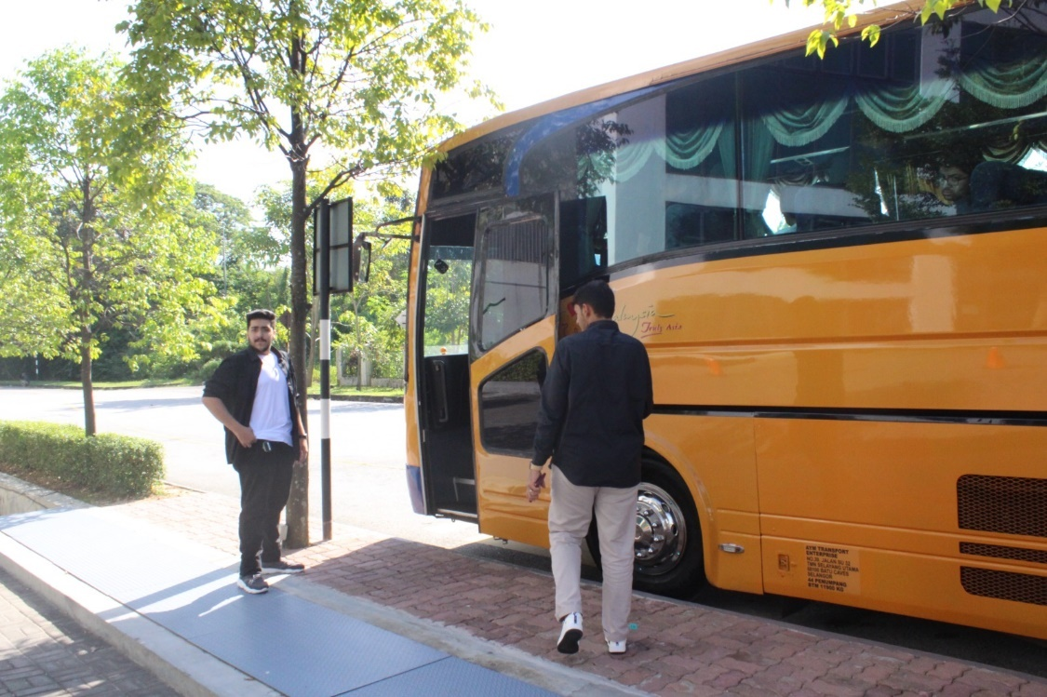

***Figure 5.1: People gathering to enter the bus***

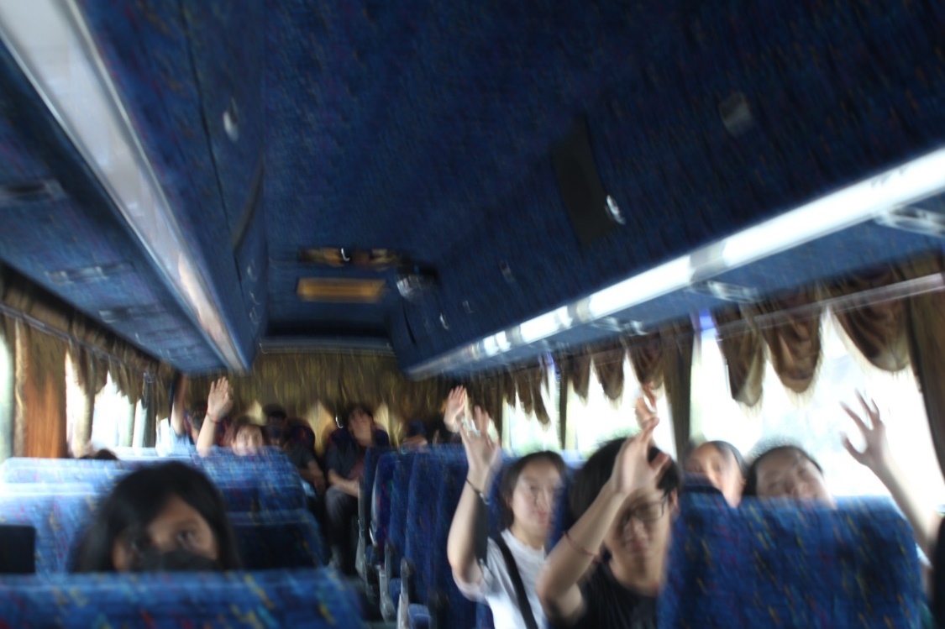

***Figure 5.2: Answering a quiz during the journey to the Museum***

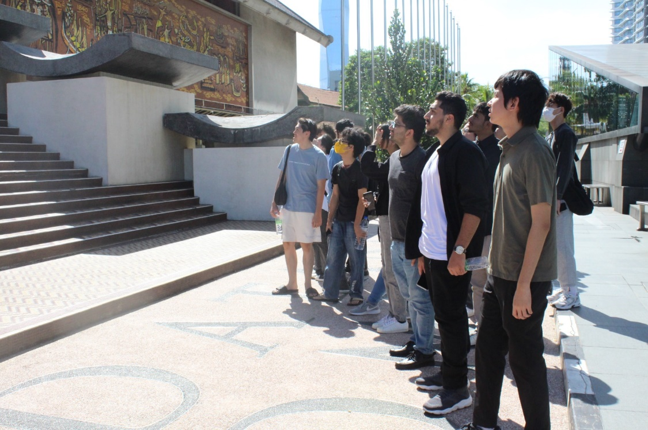

***Figure 5.3: Arrival to the Museum***

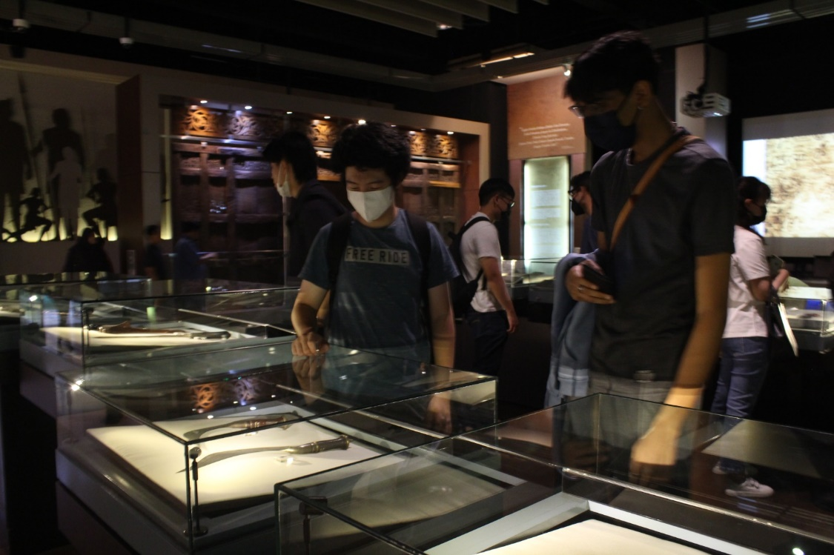

***Figure 5.4: Students interaction with pre-historic artifacts***

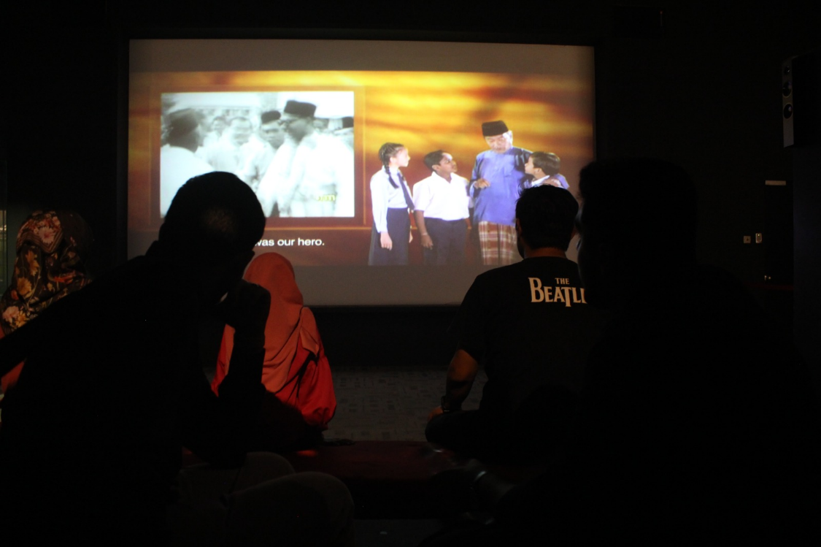

***Figure 5.5: Watching a documentary of Malaysian independence***

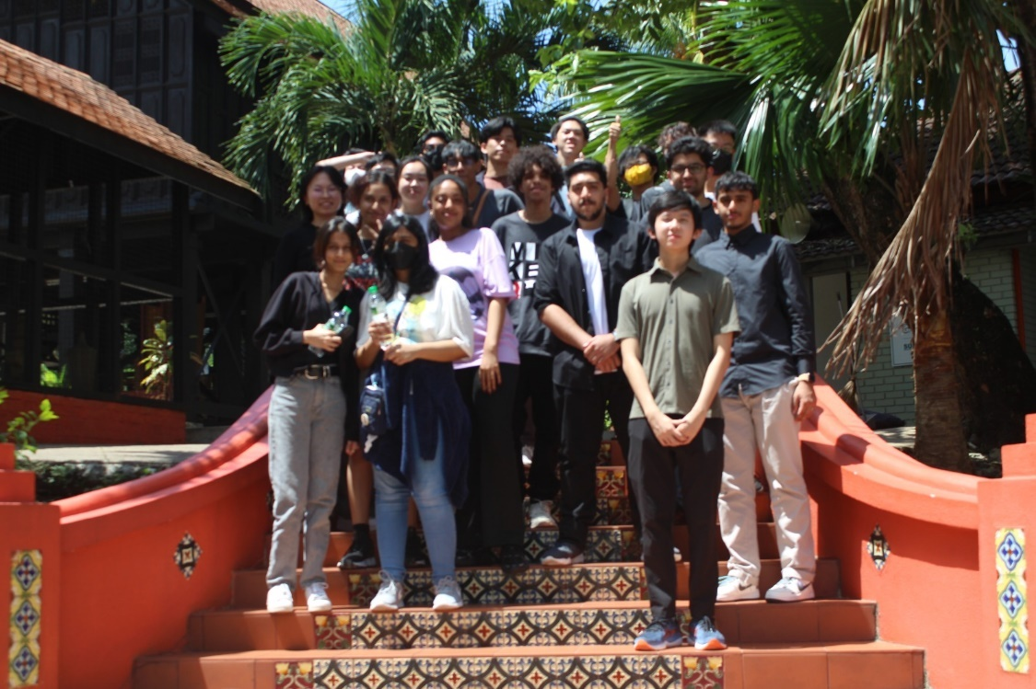

***Figure 5.6: The group photo we took at the end of the day***